DAMAC Islands Digital Marketing Campaign
  - Investor lead generation across multiple international markets

CAMPAIGN FOCUS  Qualified investor leads | CHANNELS  Meta Google LinkedIn CRM | REPORTED OUTCOME  AED 200 CPL | 180+ deals
CASE STUDY
From broad reach to qualified sales outcomes

CAMPAIGN OVERVIEW

01 Summary
  - The campaign moved beyond low-cost lead generation to optimize for qualification and sales progression.
The DAMAC Islands campaign aimed to generate property buyer leads across multiple countries while improving the efficiency of growing paid media investment. Early campaigns produced leads at a low cost, but many did not qualify. The work therefore expanded from lead volume into lead quality, sales progression, and the way inquiries were assigned to agents.
Broad targeting helped reveal which audiences and messages showed promise. Qualification feedback, CRM signals, audience analysis, and more specific creative were then used to reduce wasted spend. Following these optimizations, CPL settled at around AED 200 and more than 180 deals were closed. Changes to lead assignment were associated with a further reported 5-10% improvement in qualification and sales.

Campaign at a glance
Project | DAMAC Islands Dubai
Campaign focus | Investor lead generation for an off-plan property project
Markets | Multiple countries
Channels and systems | Meta Google and LinkedIn Ads plus CRM
Reported outcome | Approximately AED 200 CPL and more than 180 closed deals

Goal
The primary goal was to generate qualified investor leads for the DAMAC Islands project. As paid media investment increased, the campaign needed to identify which advertising activity produced leads likely to buy and understand what happened after those leads entered the sales process.

DISCOVERY AND DIAGNOSIS

02 Initial Approach
  - Start broad enough to discover demand, then narrow decisions using lead quality and sales evidence.
The campaign began with a broad awareness audience rather than limiting delivery to a narrow investor profile from the outset. This allowed the team to observe how different audiences responded to the DAMAC Islands ads and avoid ruling out potential buyers based on assumptions.

What the early tests revealed
Approach | What happened | Commercial implication
Broad awareness audience | Low CPL but a mix of genuine prospects job seekers and irrelevant inquiries | CPQL remained high despite inexpensive leads
Niche audience groups | Better qualified inquiries but higher CPL | Narrow targeting alone did not guarantee acquisition efficiency

Pain points identified
- Lead quality was unclear. CPL measured the cost of an inquiry but did not show whether the person could become a buyer.
- Sales feedback lacked detail. Underperforming campaigns were often described simply as producing “bad leads,” without qualification data tied back to the ad source.
- Lead handling affected outcomes. Broadcast nurturing generated a good response, while individual agent results varied.
- Costs varied widely. Individual leads ranged from approximately AED 25 to more than AED 500.

CAMPAIGN OPTIMIZATION

03 What Worked
  - Audience signals, intent-based messaging, cross-platform retargeting, and CRM feedback improved decision quality.

Using engagement to identify potential buyers
Video ads supported awareness while creating audiences based on viewing behavior. People who watched 75% of a video were treated as engaged viewers, while those who watched 100% were treated as highly engaged. These groups became more focused audiences for later campaign activity.

Retargeting high-quality website visitors
The Meta Pixel was installed on the DAMAC Islands landing page to track high-intent visitors arriving from Google and other marketing channels. Dedicated Meta retargeting audiences were then created to reconnect with these visitors through relevant property and investment messaging.
Repeated brand exposure across platforms strengthened familiarity and trust, making prospects more comfortable registering their interest. This brought high-intent visitors back into the lead generation journey and increased the likelihood of conversion.

Matching messages to buyer interests
- Investors: Return on investment and the property investment opportunity.
- Luxury buyers: Lifestyle-focused messaging.
- Potential end users: Amenities and nearby attractions, including schools and hospitals where relevant.
Lookalike audiences based on specific audience groups expanded reach beyond the initial segments.

OPTIMIZATION FRAMEWORK

04 Closing the Feedback Loop
  - Campaign decisions improved when platform metrics were combined with CRM qualification signals and sales-team performance.

Bringing qualification data into campaign decisions
The CRM was connected with Meta to pass lead qualification signals back into the advertising process. This allowed the team to evaluate campaigns using sales outcomes as well as platform lead metrics.

Reducing wasted spend and improving creative
Targeting options were reviewed to identify where budget generated leads without sufficient value. Unproductive spend was reduced, while ad frequency, click-through rate, and cost per thousand impressions were monitored to identify which ads were working and when creative should change.

Improving the sales handoff
Agent qualification rates were analyzed by language and location. Leads were then reassigned using those patterns to improve the fit between prospects and the agents handling them.

Optimization cycle
1  Discover | 2  Qualify | 3  Optimize | 4  Reassign

RESULTS AND LEARNINGS

05 Results After Optimization
  - The optimized campaign balanced acquisition cost with lead quality and sales progression.
AED 200  Approximate CPL after optimization | 180+  Closed deals reported | 5-10%  Further improvement linked to lead reassignment
Before optimization, individual leads ranged from approximately AED 25 to more than AED 500. Following the campaign changes, CPL settled at approximately AED 200. The DAMAC Islands campaign resulted in more than 180 closed deals, according to the reported backend figures.
Lead reassignment was associated with a further reported 5-10% improvement in qualification and sales. A campaign period, total spend, qualified lead count, and before-and-after CPQL were not supplied.

Key learnings
- Broad targeting supported discovery. It uncovered potential opportunities, although its low CPL concealed a lead-quality problem.
- Niche targeting improved relevance. Its higher acquisition costs still required close monitoring.
- Qualification data strengthened optimization. The best decisions combined ad performance, CRM signals, and sales-team insight.
- The sales handoff mattered. Messaging, spend allocation, nurturing, and agent assignment all influenced whether a paid-media lead progressed toward a sale.

PERFORMANCE EVIDENCE

06 Platform Snapshots
  - Selected Meta Ads Manager views used to compare lead cost, qualification, and warm-lead performance.
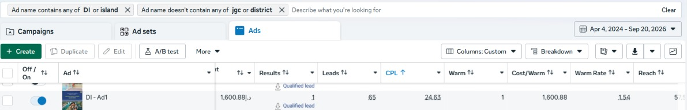
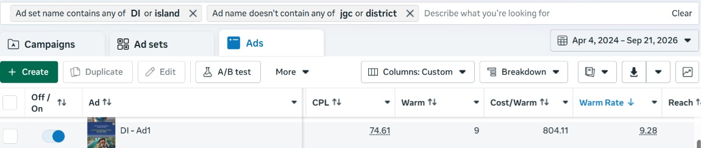
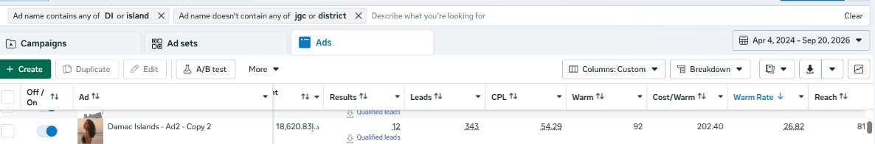
  - Platform screenshots are included as supporting campaign evidence. Values reflect the views captured in the source document.

CREATIVE EXAMPLES

07 Sample Creatives
  - Static formats used alongside video ads during the DAMAC Islands campaign.


